

Fig1

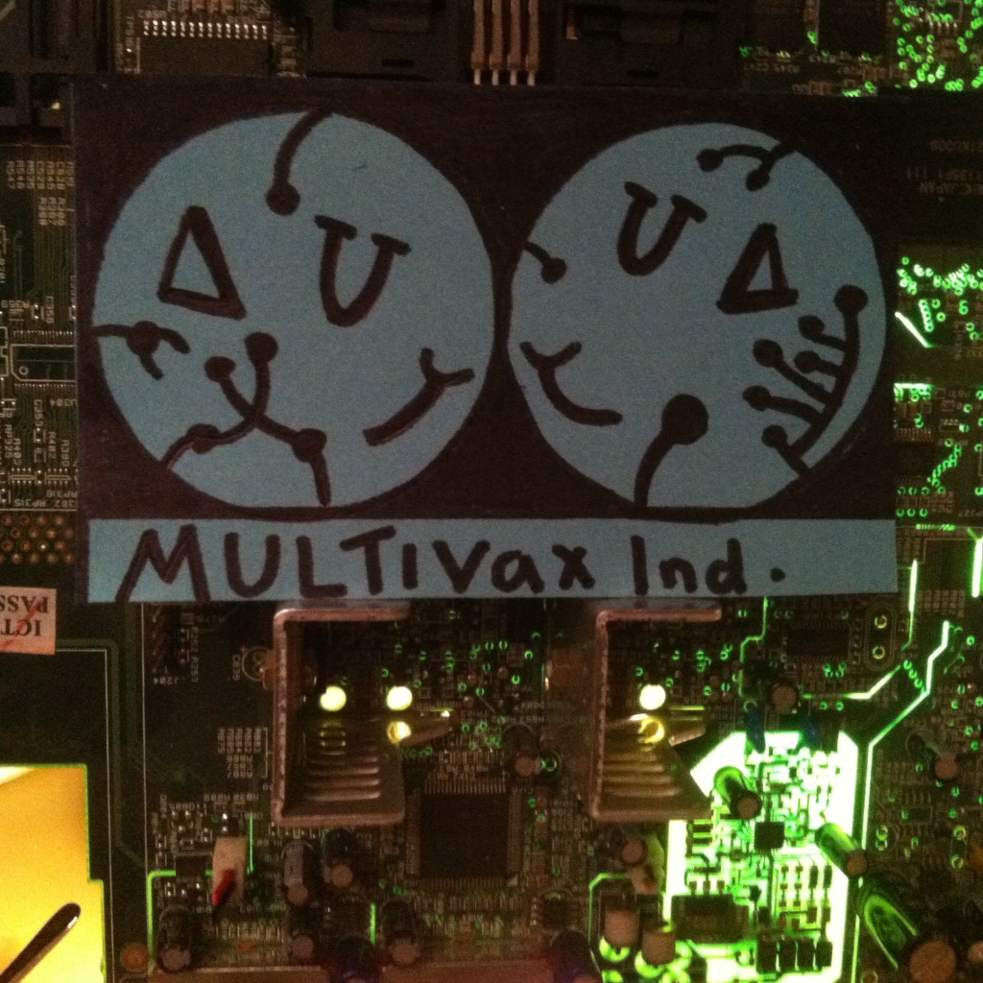

Fig2

Multivax IND.
Research Brochure

Playing for a better tomorrow!

Contents:
Pg1- Cover
Pg2- Contents
Pg 3- Does not exist<ERROR>
Pg 4- ‘0 Days without an accident’
Pg 5- Practice in Context
Pg 6- Welcome to Multivax Ind.
Pg 7- The ‘@HOM3’ project
Pg 9- (some photos)
Pg 10- So what is a game/play?
Pg 11- Multivax Ind. Presents Interactive Artefacts
Pg 13- Budget
Pg 14- Mr Sandman…
Pg- 15There is no magic, only lost physics
PG 16- Would you kindly?
Pg 17- 427
Pg 18- How can we create better experiences as performers? By offering the audience more sportsmanship as opposed to spectatorship?
Pg 19Exploring, adapting and gaining inspiration from other art for the basics of my own Narrative.
Pg 20- Welcome to Neverware?
Pg 21- The adventure comic & concept art
Pg 22- An Evaluation.
Pg 23- Bibliography

Foreword

Dear Player,

You have been selected to interact with this: DVD<BOOK<TOY<ARTEFACCT<CHATTERBOT<DOCUMENT<CONSOLE<(OTHER-PLEASE SPECIFY…………………..) (Delete as applicable)
We are so happy you have chosen MULTIVAX IND. As your play supplier. We hope that your experience of any of our equipment meets all your play needs, and just need to ask a few questions before we begin.

Do you like play/games/immersion or fun activities?

Yes/no

Would You Like To Start A New Game?

Yes/No (Please delete a applicable)

Do You Think Games exist if they are not played?

Yes/no

Thank You, Just one more.

Does every game need to be completed?

Yes/no (Please delete as applicable)

Explain.

0 Days without an incident.

So here we are, my final year at Falmouth University. It has been an interesting journey, not quite what I expected but I am grateful for all the lecturers (past and present) and the knowledge they have given. They have all influenced my work somewhere along the way. And like most things recently, my project started off rocky.

Whilst waiting for my finances to be in place (they were delayed for a month), I began researching play and performance whilst both being inspired and thinking about in the context of play, Samuel Beckett’s ‘Waiting for Godot’, The Portal series and an installation piece I saw on the Moor in Falmouth by Julian Gaskell during the Tall Ships festival involving him, his dog and a mechanical orchestra. I began to wonder what immersion really meant and whether I could use play techniques in performance to explore what performers can do when the audience are expected to take interaction over spectatorship if we call the performance a game.

I hope you will find this document an interesting array of research and performance ‘material’ that records where Multivax Ind. is at this point in development of the @HOM3 project. I would like to begin by quoting Greek philosopher Heraclitus -‘“The Only Thing That Is Constant Is Change ”. This statement summarises the process of my PIC to this point, now. And I’m sure that by the time you have read this more will have changed. However, the changes have made an interesting project and I want to thank all those involved (still involved, and ready for the next part).
This project has changed a lot from my original proposal form, and certain aspects I wished to work on in my update form, have taken other routes. But I want you to know now, reader, that I have a view to the future with this project, so am carrying on as we speak. I was quite ill during this process so there are gaps and some pieces that I wanted to produce, never saw the light of day. However, a lot of this work I hope to use in one way or another in the near future.

I wanted to create performance material that displayed and incorporated all the research that my company had done through deconstructing narrative, games and theatre by exploring them through the lens of play.

I will define some key terms and phrases and explore culture, experiences and games throughout this document that have inspired this project. To begin however, I would like to remind you of what the @HOM3 project is all about. This exciting adventure has been both an experience and, in many ways, a game in itself.

I have really enjoyed creating this project conceptually, the art, the music, the story and so much more I will discuss later. So thank you: Phillip Murphy, Will Samuels, Charlie, Ben Pictor, Sam Hughes, Georgia Griffiths, Katie Chandler, Imogen Parnham, Amy Hepburn. All those that donated and helped with this project. I am happy to say that House will have his moment in the spotlight.

We are all Multivax, and certainly part of the game!
PIC – Practice in Context.

When we started this module, I was constantly keeping in mind that we were to explore our own practice in the context of research and presentation to create a project that both furthers our understanding of our own work (with all of the different viewpoints of social, political and historical) and think about presenting/collating findings in ways that linked to said practice, be this performance, interviews or other means of ‘documentation’.

I am presenting my research directly through my various game ‘material’, as it is hidden, it is simply down to the viewer, participant, volunteer, performer, gamer to explore, find and learn. By immersing yourself further into the material you begin to blend with the spectrum and see the world of the game, as it bases itself in your reality. YourHOM3.

Play is about learning boundaries, overcoming obstacles and giving your time and devotion to the circumstances at hand. I wanted to blend performance reality and real life to give a series of experiences using trans-media story telling as its format. Work hard, play hard right?

Punchdrunk and Coney have been two performance companies that have certainly inspired the work I created. The work they produce is immersive and complex, using modern technology to bring play into everyday life, but also create spaces those audiences can then step into and become something…different.

Coney’ are interactive theatre-makers. We create games, adventures and play where people can choose to take a meaningful part. Our work takes place anywhere that people gather: in theatres, schools, museums, on the streets and online and always follows the principles of adventure, curiosity and loveliness.’

Coney (2016) About Us, last accessed: 21.01.16, URL: <http://coneyhq.org/about-us/>

They have been looking at pervasive games and enticing play into our everyday lives, @A Small Town Anywhere, saw an entire town created by player, all role playing and becoming the characters in front of each other, with their choices effecting the story.

Welcome to Multivax IND.
Having conjured this idea in my second year module with Misha Myers, I wanted to explore my hobby of building/up-cycling old material (computers, toys broken equipment, suitcases, old mixing desks etc.) and turning them into something ‘new’. ‘Play-bots’ are my creations, mostly coming to life to communicate and in some way aid the play of my gamers. I wanted to explore the way in which an audience can immerse themselves in the narrative I have created, by exploring/interacting with the ‘distorted reality’ I have created for them.

‘The human body is built to interface with its environment’
Giannachi, G. (2004) Virtual Theatres: An Introduction, Routledge, London.

Stellarc’s ‘Cyborg Theatre’ initially provided me with some interesting things to think about, such as how do humans and machines work if we choose to play through exploration? Does technology limit us in this case? I wanted to show the effect of an audiences choices, conversation and rate of immersion to present the idea of better experiences for both performer and audience member, when the concepts of a ‘game world’ are allowed to seep into our own reality, as we lose time together concentrated on an objective.

‘Through Immersion the fan enters into the world of the story, if even briefly, suspending disbelief and forgetting their real-world circumstances. In the way a good movie seen in a darkened theater can swallow us and make us feel present in that scene, transmedia design should aim to draw a fan in deeply enough
to forget his- or herself.’
Moloney, K, (unknown) URL:http://transmediajournalism.org/contexts/principles-of-transmedia/#5 , last accessed :25.01.16
This is why I formed Multivax Ind. a company based on the sole exploration of play and interaction, to create/produce/distribute performance research ‘material’ as evidence and ways of teaching people about the theories behind why we play. I would also incorporate the company itself into the story we were creating, as though it were a ‘supplier of fun and interesting playthings’. This provided us with a narrative structure that we could go by.

The company is formed of various members of Falmouth and Exeter students, ranging from events management to performers, artists, musicians and dancers; all giving their skills to the creation of live interactive, puzzle solving experience, film, music, comics and podcasts (as well as a website and eventually, a videogame/app).

The aim was for HOUSE (our artificial intelligence character in charge of the facility) to tap in to various forms of media and ‘upload’ his playful presence for all to see, sharing information and footage of our ‘play-sessions’ and the other components of the project displayed in the ‘@HOM3 Project aims and goals’ which can be seen on page 8.

Pulling inspiration from various other forms of art, literature and other media explored later in this documentation I wanted to create a performance experience that felt like a puzzle when you received the full package(planned to sell during our complimentary practice module). I started creating the research material and trying out styles of media through the process to see how I could incorporate all I had explored with some sort of playful nature that ultimately created a project people had to interact with if they wanted to find out the full incident.

I have used the company throughout the narrative and wanted to create a distorted vision of this within the game, using the Performance Centre as our facility and filling it with various objects and created artefacts. An audience could then lose themselves in our story and take ownership of the performance as it requires their interaction and relies on their acceptance of our distorted reality.

In the future I also plan to work with creative events management and run a technical stall and run a workshop selling and creating with passers-by to create new pieces and further the audience of the whole project.

I ran the company, with regular meetings with the actors, where we would collectively devise script and music, characters and dialogue for the various aspects of the project. The idea also being that everyone involved would get copies of all the material to reproduce at their own will and use for personal artist portfolio’s.

The @ HOM3 Project
Distributed Narrative

Aims/Goals for the project as a whole:

‘Transmedia Franchise: Whole is more satisfying than the sum of the parts; euphoria of collecting the pieces.’
Rutledge, P (2016) URL:http://transmediaexperience.com/transmedia-3/what-is-transmedia/Last accessed: 25.01.16

Podcast
Phillip Murphy’s soundtrack
Performance (live)
and recorded

Highlighted in green are material that have been created for PIC specifically
Red are for PPP
Blue is Complimentary Practice

Selling the @HOM3 Material
Adventure comic

Fig3

What does trans-media mean?
‘Transmedia storytelling uses multiple media platforms tell a narrative across time. Each media piece—whether it’s a comic, novels, video games, mobile apps, or a film—functions as a standalone story experience—complete and satisfying. Like a giant puzzle, each piece also contributes to a larger narrative. The process is cumulative and each piece adds richness and detail to the story world, such as character backstories and secondary plotlines.’

Rutledge, P (2016) URL: http://athinklab.com/transmedia-storytelling/what-is-transmedia-storytelling/, last accessed 25.01.16

We wanted to use the Performance centre as Multivax Ind’s facility. House, our resident AI throughout the project, has integrated with the building and is layering virtual onto real. His creations are seeping through the different aspects of the project, and the line between his game world and our own, have been blurred.

‘Transmedia storytelling is fully participatory. The audience becomes actively involved, elevated to social and creative collaborators. They become stakeholders in the transmedia experience alongside the brand or cause. The unfolding story design creates the motivation to engage with other participants, seek out other parts of the story, and contribute to the narrative by adding content. Transmedia stories can be simple, across a few low-tech media platforms or break down the barriers between the story and reality by bringing the narrative out into the real world, in the form of complex and exciting alternative reality games (ARGs), where participants engage with narrative elements and characters using real world locations as part of the storyworld.’

Rutledge, P (2016) URL: http://athinklab.com/transmedia-storytelling/what-is-transmedia-storytelling/, last accessed 25.01.16

I am going to, by the time of dissertation and complimentary practice, sell the whole story (in pieces) to those that supported the project and those who wished to purchase the @HOM3 package. The live performance would see House running the facility as 6 players enter and try to shut him down, saving the developers and freeing the hostages (previous players). This would be recorded and sold as ‘found footage’, along with the various other components. Audiences would then receive the whole package, with bonuses if they wish (actual set pieces, posters and costumes etc.), and be able to piece Multivax’s story back together whichever way they please. I thought this would bring a different experience of immersion, and hoped to get reviews back after the projects end to see what people thought.

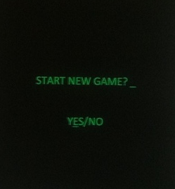

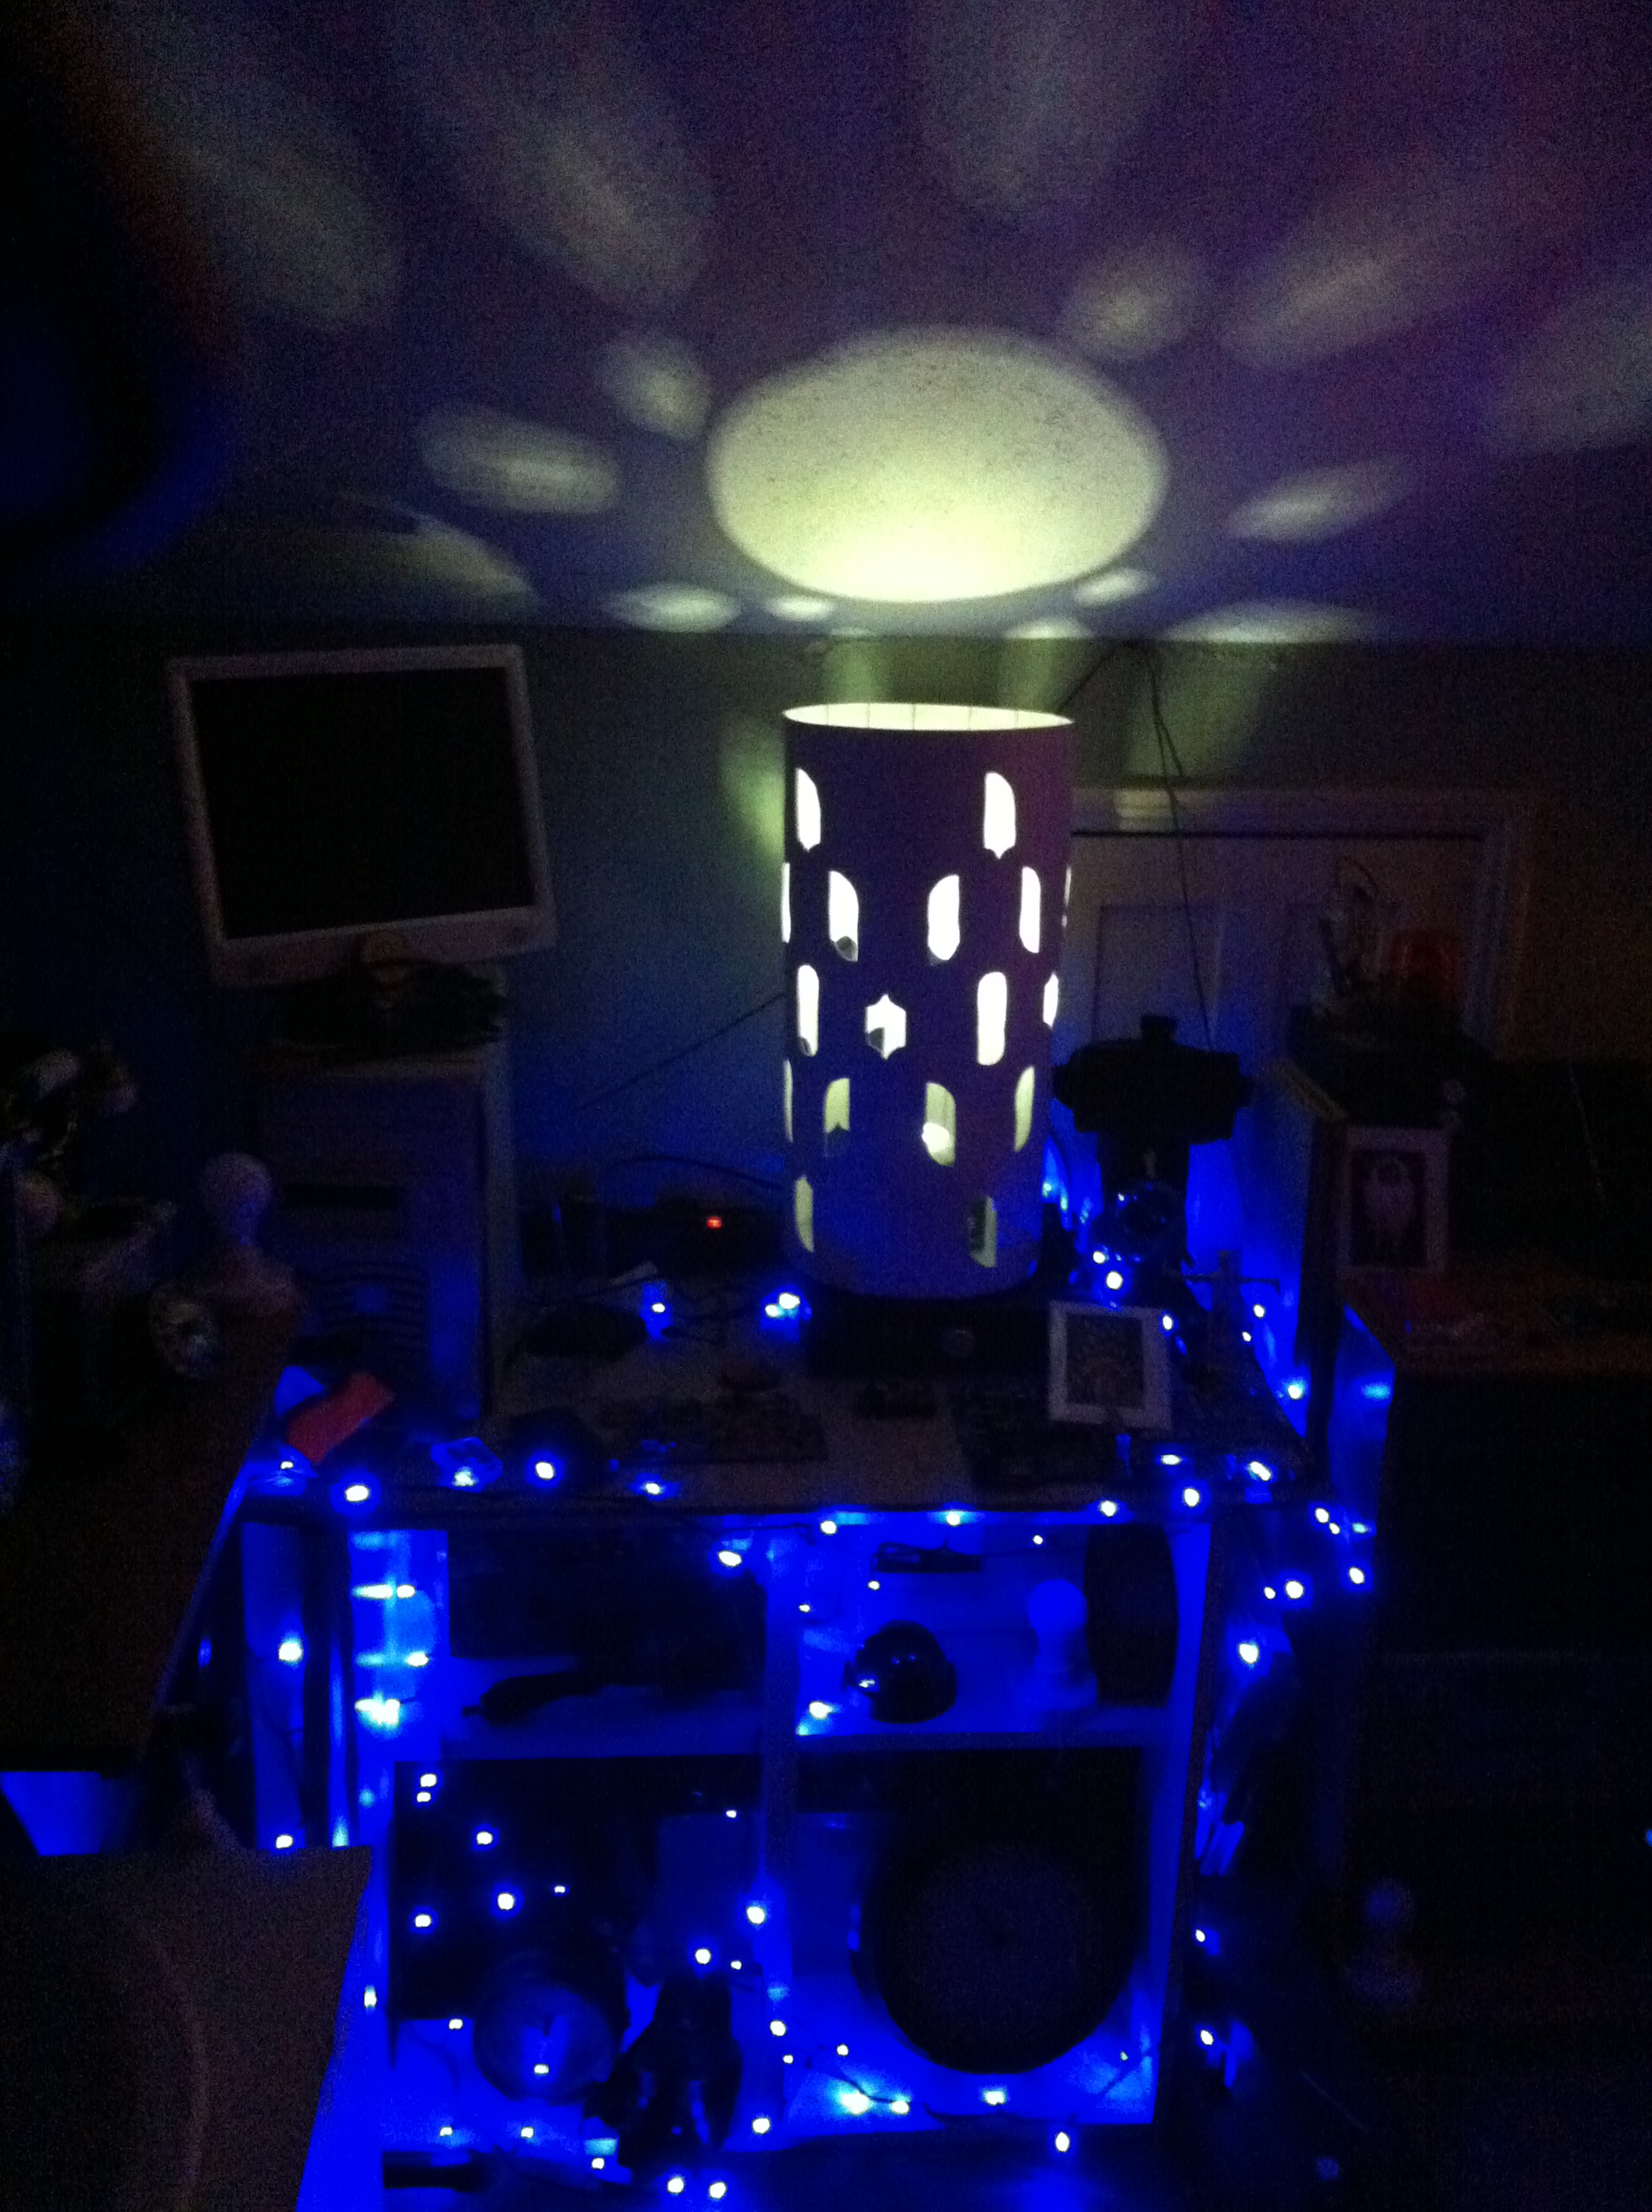

Fig 4

So what is a game/play?

Callois- man play and games
I concentrated my focus for definitions to a select few, but Roger Callois’ argument in his book, ‘Man, play and games’ expands upon the studies of Huizinga, and develops his theories of what play is further, delving deeper into plays role in society and everyday life. I wrote scripts and designed rooms around Callois dispute of Huizinga’s original theories of why and how we play.

Salen and Zimmermanndescribes a game as “an activity with some rules engaged in for an outcome” and they further define a game as a “system in which players engage in an artificial conflict, defined by rules, that result in a quantifiable outcome”.
Salen, K and Zimmerman, E. (eds.) (2006) The Game Design Reader, MIT Press, Cambridge, Massachusetts.
MIXED REALITY PLAY
Setting it in the NOW
Mixed reality is an interesting term I have come into contact with recently. I decided to explore it further and realised it could be an interesting narrative structure in itself (with all of the different forms of media and communication I planned to use). It explores the notion of different ‘realities’ existing when games are to be played.
There is our reality, where we exist as players.
There is the game world.
And there is a place where we are playing, between the two.

By setting my games narrative in the now, it also allowed the possibility of strengthening the theories of pervasive games and play in everyday life. Pervasive games tend to incorporate portable tech to use in your homes, at work or on the go. I wanted to manoeuvre the audience using different portable tech explained shortly.

My project wanted to break down the wall between the game world and our own perceived reality, to offer something a little different. An experience that would see people slotted into a self-contained set of challenges with an overarching narrative (that unfolds not just in this experience, but across a wide range of different media) that educates players in game theory and asks the question: what sort of player are you?& do games exist if they aren’t played?

The magic circle is something that mixed reality and pervasive games attempt to change a little from Callois’ original ideas. He describes it as being the ‘space’ (be this in terms of the limit of where the rules take you and in the game world, or a physical space) where play exists. However, someone can drop out of it by saying ‘I don’t want to play anymore’. Mixed reality play looks to make the magic circle an invitation to play as opposed to a boundary for play.

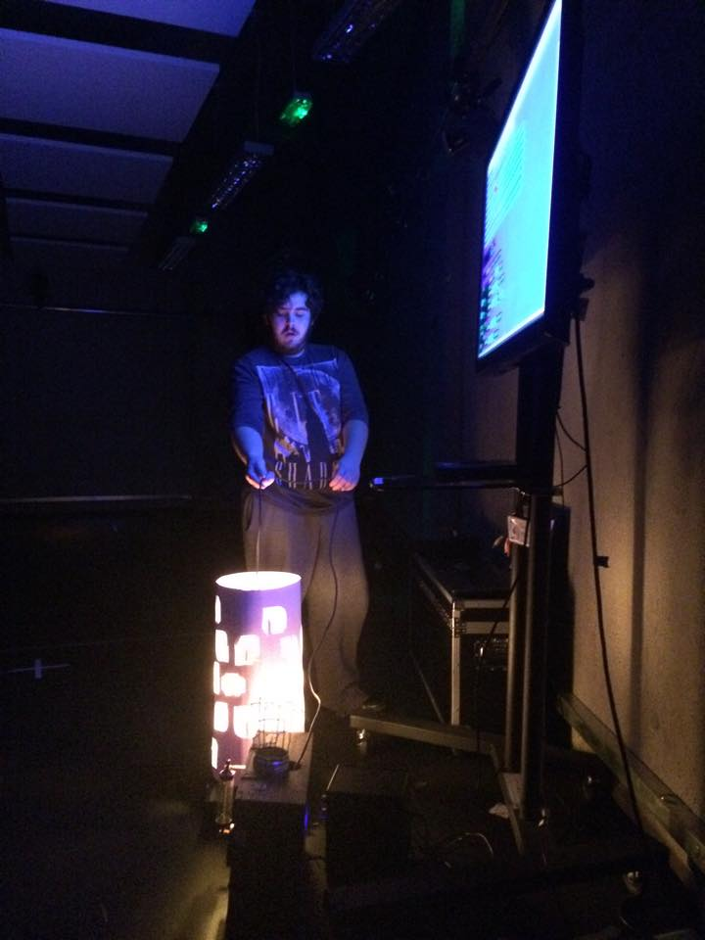
Multivax IND. Presents Interactive Artefacts

‘Augmented Toys (e.g., [2, 32]), for example, “combine the best of two worlds – traditional toys and the power of computers and electronic chips –“ [4] while also enticing imagination and supporting social experience (playing with friends) andImmersion due the high degree of freedom. However, we argued before that the transition from the physical to the virtual world is continuous, which makes it potentially hard to realize a mixed reality environment where all dimensions are equally met.’Hinske, et al. (Unknown) Classifying Pervasive Games: On Pervasive Computing and Mixed Reality, last accessed: 21.01.16, URL:
<http://www.vs.inf.ethz.ch/publ/papers/hinske-
pg07-pervasivegames.pdf>
Fig5

I created various equipment or ‘Playthings’ that would be used in performance for audiences to interact with. These are some of their roles:

HOM3 (Holographic Object manipulator X3):
There are 3 holographic object manipulators, these are what is calculating and outputting the virtual space and modifying the surrounding environment in our reality to create the play space. A magic circle manipulator if you like. It layers the virtual and our reality on top of one another and lets it seep through the cracks, until you can’t tell what is real or not what it seems. You have to deactivate them (one on each floor) Problem is you won’t know what they look like; you will have to console your GUS unit to scan possible HOM3 units.

The ludus complex & Complexity Device:
House is a godly machine. He has the power to recreate whatever he wishes, but he is young. The very essence of play is pushed into a machine and has godlike creation skills, but is restricted to his format. Forever building his own labyrinth, and allowing visitors to witness/take part in his creation. How long did we really think it would take for him to start looking to our reality for an answer?
The ludus complexity device is what has been holding his existence in a fixed position. The formulae for life, experience and events is calculated by it and House is its interface, loaded with intelligence so it could fairly judge players.

HOUSE
House is a sentient, procedurally generating AI built to help us research, record and judge players (and offer a 24 hour service of free play). Its power source is event energy. Calculated with experience it allows the game to feed off your energy by simply completing his puzzles and challenges. He wishes you no harm, but he is the very essence of play. You don’t feel a thing. He is only active when played. He has built a social enterprise business around himself using various social networks and formats and is integrating himself into a fixed location. He is the whole building, and is what has created this experience for you.
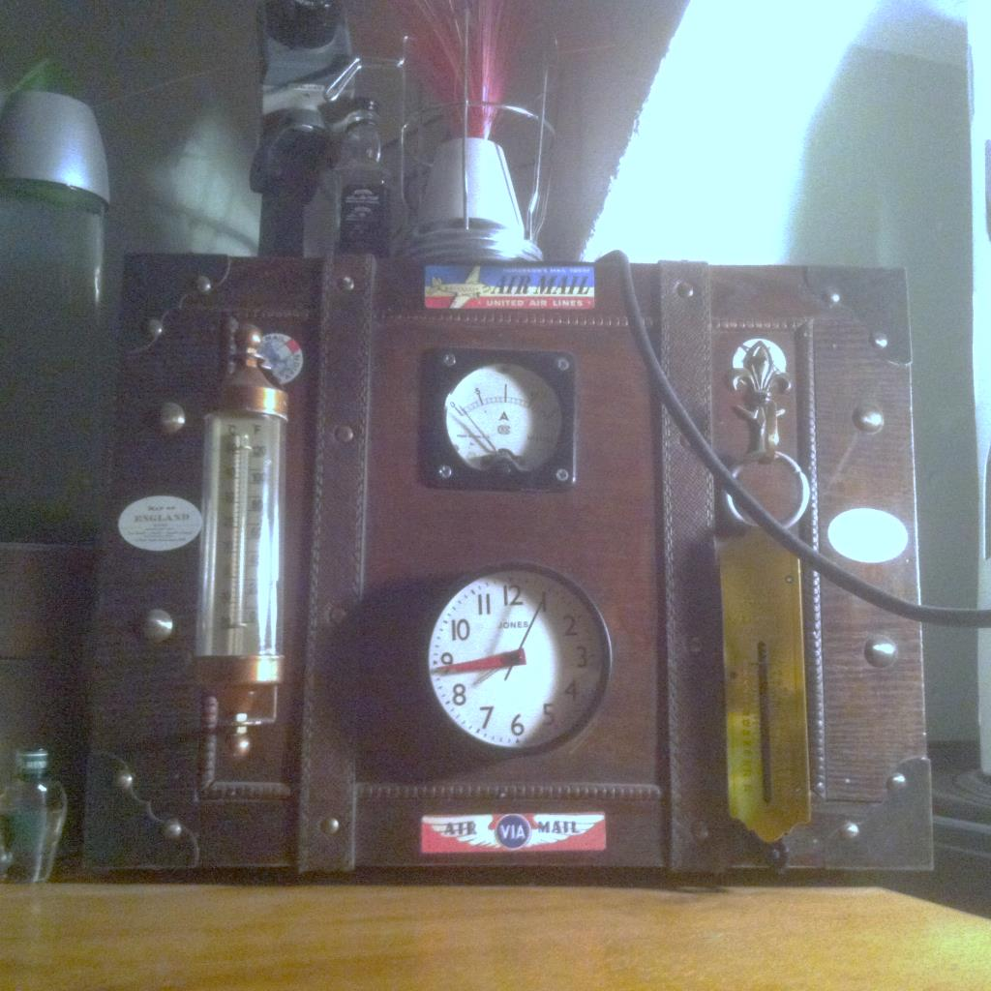
GUS (Guided Utility System)
A partially sentient chatterbot, created from scrap material and your live, personal guide through the game.I would voice his character during the performance, hidden from the audience. The version you see in this document is also the same as the GUS unit we hear about in Neverware (explained later on). His function is to provide us with a live link to players, but also allows players to not break their immersion if they become stuck or confused, because they can just ask GUS.

Fig 6

Unasteamed (House’s integrated foot soldiers)
Previous players of House’s games, they are what you become if you are fully integrated into his system. Completely devoted to his play, you lose everything that makes you who you are (emotions, dreams) and replaces it with the need for one type of emotion. The desire to win. And he controls who your enemies are. With their fight or flight mechanisms scrambled they only know to do, act and play. And they will stop at nothing to win.

The dream machine:
This stroboscopic device was one of the first designed artefacts that would run the game, originally created by Brion Gysin.As a device that had some sort of illusion effect on the eyes. I took this design and made it so that it, combined with the ludus complexity and@HOM3 console, allowed House to take the designs and input that we created and virtually layer the room with them in our reality. The light projects out the material.

‘This initiative shows you are playing, and have started a new game with us,’(Multivax, 2016)

Budget:

All of the materials and ‘Artefacts’have either been donated or werebought and made by me. This started as a hobby and originated from my first speaker box which cost £50 to make. My original intention was to do a live performance, of a scientist and his creation (a suitcase that could talk) at the end of time, trying to find a way to survive when all that’s left is one man and his machine. After the show the machine would be sold as an artefact that managed to fall through time and space.

I set up a kick-starter page for the project, to encourage the sales of the material after PPP. My original campaign was unsuccessful, I did learn about this sort of funding (as I have never used it before) and what a ‘reward’-‘donation’ system was all about. I will certainly come back to this later in my practice as it was interesting to see how much the site offered in terms of contacting and advertising what you are trying to raise for.

I intend to sell the various pieces of the @HOM3 project in my complimentary practice module, so to finish the story for now, with all of Multivax’s equipment and material auctioned off. A performance in itself.

The whole @HOM3 project will be on offer for people to interact with and piece back together, our broken little story in the comfort of their own homes.
Mr Sandman…
Doctor Who and breaking the fourth wall.

‘So now we all have evil sand beasts growing in our eyes, and it’s nobody’s fault but our own for getting caught up in the storyline. We always knew that narrative would be the death of us’.
Radio Times staff,(2015) URL:(http://www.radiotimes.com/news/2015-11-14/7-questions-we-have-after-doctor-who-sleep-no-more) Last accessed: 21.01.16

Sleep no more, doctor who- using fairy-tale in a sci-fi theme that then breaks the fourth wall and turns the ‘transmission’ into an infection.

‘In keeping with the found footage aesthetic, Sleep No More was the first episode of Doctor Who not to feature the iconic openingcredits and theme tune. Instead, it was straight into the action via a "cold opening", an affectation cherished by self-consciously edgy television.’
Power, E, (2015) URL: http://www.telegraph.co.uk/culture/tvandradio/doctor-who/11990021/doctor-who-sleep-no-more-review-recap-reece-shearsmith.html, Last accessed: 21.01.16

The episode exists in the ‘found footage genre’;I wanted to use this in a similar way with the project. This was the plan on how we would release the recorded version of the performance to a wider audience, making it a one off live performance that’s then offered to people at Home via a dvd of ‘found footage’ (which House would use to infect players through them watching/interacting with his games). I thought the title sequence in itself was an interesting point, and wanted this to be the sort of thing I could have as bonus features for audiences who watched our performance.

Play powers House’s existence. If you don’t play, or stop playing, then he gets weaker. So through interaction, the question begins to be raised, who can stop him? When did you start playing? When did our game start for you?

I’m a big fan of Doctor Who, and its writing recently inspired me a lot to do this. Our hero the Doctor has never felt so much like his older regenerations during the recent adventures, which gave me the idea of making each piece of material we create like a separate adventure. (Peter Capaldi’s performance has certainly inspired the Toymaker’s character, admit it, you have always wanted to be like your heroes?) Watching the classic episodes with my Dad always makes me chuckle when some small hark back to say, Tom Baker in the show bring a lovely sense of nostalgia.
There is no magic, only lost physics.

Play is also all about learning; trying new things, sometimes in a new environment. Portal does this expertly, by first training you in its mechanics (bit by bit) and then allowing you to incorporate all you have learnt to bend the environment to your will using the Aperture science Portal Device.
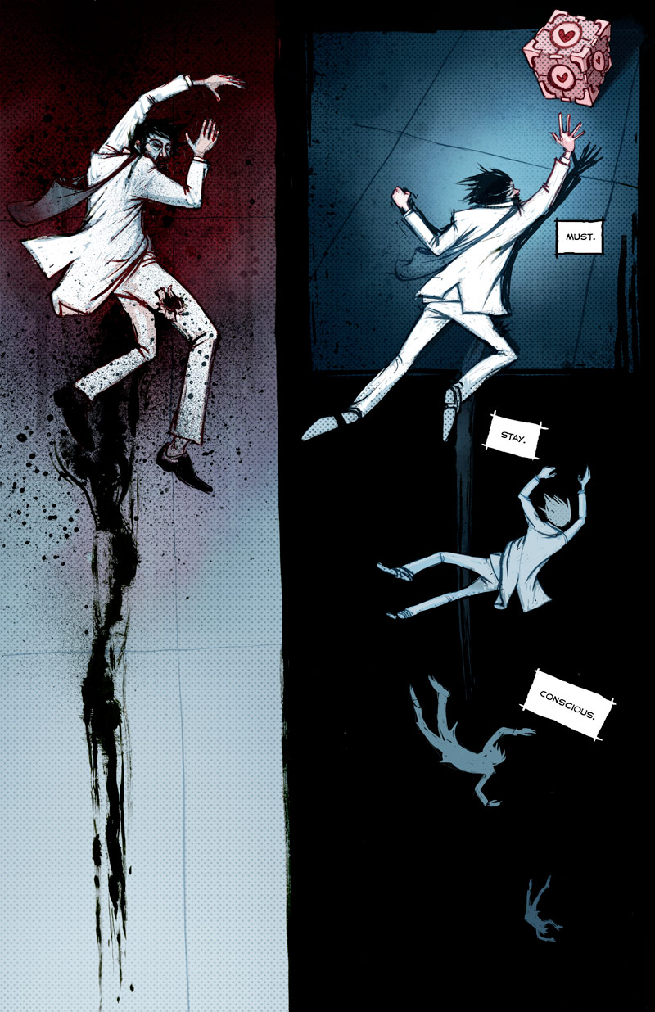
Richardson, M. (2011) Valve Presents: The Sacrifice and other steam powered stories, Dark Horse Books, Milwaukie
Relying a lot on exploration, the game can have you puzzled for hours just trying to ‘think with portals’, I wanted to contact Valve to ask them how they had made a game that had complex algorithms and dimensions within it, but somehow also managed to make the narrative and music (the general aesthetics of the game) fit so perfectly. As my game would rely on exploration of space to your advantage, this game provided me with some interesting insight into allowing audiences to gradually learn dynamics and game mechanics, piece by piece. Extra Credits are a YouTube channel that offers interesting mini lectures (with animation) on various games and game theory.
- Please watch: Extra Credits (2014) Design Club – Portal: Test Chambers – Tutorial Mechanics, last accessed: 21.01.16, URL:
<https://www.youtube.com/watch?v=Q_AsF3Rfw8w>

I didn’t get a response from Valve, but I did find a copy of the ‘Valve’s ‘The Sacrifice, and other steam powered stories’. They teamed with Dark Horse, to bring to life a Portal comic, linking the first and second game. ‘Portal: Lab Rat’ gave me the idea for the mysterious presence of someone helping you from behind the scenes, as we learn about Doug Rattman, the remaining employee of Aperture. It also inspired the style of graphic novel/comic I wanted to explore. The artwork is incredible and the story is intriguing. A definite inspiration for this project.

Would you Kindly?

The Bioshock series and the choices that define us, both as the characters we play, but as players ourselves.

Bioshock’s process of storytelling through game narrative is an interesting blend of spatial exploration (and al the supplies and information you find just lying around Rapture & Columbia on devices that you interact with or through dialogue with some interesting characters) but also smaller choices in gameplay that can change your story and experience of the game entirely.

Your choices tend to affect which ending you get, but change your mind-set as you play through (namely freeing or harvesting possessed children guarded by giant metal monsters). Layer this into the beautifully disturbing underwater city of Rapture, full of corruption and creatures twisted by madness and ‘plasmas’. This game creates a weird nostalgia of a place you never get a glimpse of when it was in its prime.

The music alone tells a complex tale of a promise of a better place, away from war and poverty. It certainly inspired what myself and PhillipMurphy have been working on for the @HOM3 project, as the atmosphere throughout the game was changed by the interjections of songs from its soundtrack found on radio’s in rooms filled with the reality of Rapture.

One of the most iconic scenes in Bioshock’s history is from the first game. Jack (your avatar) must go and find the creator of Rapture (Andrew Ryan) in his main office. You are sent by a man called Fontaine, who up until this point has been ‘helping’ you succeed in your mission to try and escape. After some altercation you must kill Ryan, as you do he screams the below quote over and over, it’s a horrifying message to player and avatar that ‘Philosophy of Bioshock’ explores.

‘A man chooses, a slave obeys’ – Andrew Ryan
I attempted to contact 2K games the same as Valve but to no prevail. What with both franchises finished (for now…) I knew this would be a longshot but they are so clever in their design I had to try.

427

Choices and narrative structure in play. The Stanley Parable and doing as you are told VS the Paidia path.

‘The Stanley Parable is a first person exploration game. You will play as Stanley, and you will not play as Stanley. You will follow a story, you will not follow a story. You will have a choice, you will have no choice. The game will end, the game will never end. Contradiction follows contradiction, the rules of how games should work are broken, then broken again. This world was not made for you to understand.
But as you explore, slowly, meaning begins to arise, the paradoxes might start to make sense, perhaps you are powerful after all. The game is not here to fight you; it is inviting you to dance’
Café, G,(unknown) URL; .http://www.stanleyparable.com/, Last accessed: 21.01.16

I personally think that the entire game is a metaphor of 'choice'. The fact that no matter what, there is no such thing as choice or free will in a video game. It has already been planned out. Stanley represents the character, feeling as if he can make a choice and be free and escape, when really, that’simpossible; it has already been made for there to never be an ending. For you to never escape, and for you to never truly beat the game. 'The End Is Never.'

Stanley’s role + the Players role = the same thing
Stanley’s job was to press buttons, just like your role in the game.

‘We play games, by their explicit rules, the way we are told to do so’

‘The Stanley Parable is everything and beyond video games. It's a giant commentary on todays game development philosophy. Throughout its unexpected span and twisty narrative, it has a clear message - there are problems with narrative in video games, which we have not addressed yet.’
Verity, D, (2014) URL:(https://www.reddit.com/r/Games/comments/1rcli3/the_stanley_parable_analysis/, Last accessed:21.01.16

This game explores player’s agency over narrative in games, and brings you to the conclusion (through various other endings) that you don’t really have control of a games story as it’s all been written previously. Procedurally generated games may break this mould, but we need the stories to go with it. We explored this through House’s tech.
The Paidia path is a sub category of games Callois explored. This is the human urge to explore and choose. Paidia is the idea of free will in play, and doing because you can. You see 2 doors, someone tells you to go through a specific one, and you chose the opposite. The Stanley Parable is all about this, and our game would rely on exploration, but also this impulse.
This is something I wanted to explore through Multivax, but get the audience to have this agency; the game relies on conversation, reaction and initiative.

How can we create better experiences as performers? By offering the audience more sportsmanship as opposed to spectatorship?

The audience, like players, invest something more into the choices they make in the virtual/ mixed reality space and choose given the predicted outcome, even though the action may be weird coming fromboth the individual, and their character.

It’s a bit like the old text based games that told stories where you were either yourself in the narrative or took on the role of a character. The story would be told section by section, and then you were given options at the end of each page asking you to make a choice, this choice would then direct you to a different page, and usually, a different narrative branch.

I have also played a video game called‘The Walking Dead’, which was created by Telltale Games in this style, but it also involves sequences where you must move your character through the dystopian universe, fighting the living dead. But as well as being a well-choreographed zombie game, it relies heavily on the choices the player makes, both in conversation and directly choosing where to go/who to follow or what to do.

With immersive experiences being a common goal of theatre and games, especially due to the technical advances in both industries, audiences are being expected to do a lot more, but what can theatre learn from games and the way they immerse players? And visa-versa?

I want to look at this sort of thing for my dissertation: How can we as performers, create better experiences for audiences if we look at play for our techniques?

Exploring, adapting and gaining inspiration from other art for the basics of my own Narrative.

Cyberpunk Frankenstein- the postmodern Prometheus.
As the other title for Mary Shelley’s story tells, ‘the Modern Prometheus’ is the tale of a scientist creating life with science, with shocking consequences. Through the @HOM3 project I wanted to look at adaptation as part of the immersive experience and so decided to take Frankenstein and imagine it as a game, both metaphorically and literally. The overall story arch was a modernised homage to this story and its main characters, the scientist and his monster. However our story would look at different sections in different light, but also chop the narrative up and switch it around.

What if the monster was able to make his own bride from the doctor’s notes?
What did House’s creation involve?
What else has he got up to when his creator wasn’t watching?

I also wanted to tie in Dominic Philpot’s PIC project as it was a similar idea to mine, so his fake asylum (Ardor) Wrote Multivax a letter asking House for help with a situation. (The document can be viewed with this document)

Fallout – inspiration for Neverware radio
I based the baron setting of Neverware largely off the wasteland in the Fallout universe. A broken and dying landscape that has a weird nostalgia scattered about it, of a corporation distorted by war and power, which test on people in ‘Vault’s’. Like Nuka cola in the games, Multivax Inc.’s presence would be seen throughout all of the different media, like a virus affecting viewers. The music in particular is a great inspiration and I have based rooms on songs from its soundtrack.

Issac Assimov- I,robot& The last question- the general idea of AI
‘The last Question’ by Issac Assimov is certainly one piece of text that has inspired the idea to create this game. The ideas and setting of the story (as we travel from perspective to perspective and go further into the future as the story continues) made me think about House and his character. I didn’t want him to be bitter about creation, but urge to survive (just like humans do). He is aware however to run his programme he needs a lot of power, and eventually would use up every single power supply on our planet, so much so that Gus and the Toymaker were the only ones left just before the collapse of our known universe. I wanted to show this moment as a ‘game death screen’ using the peppers ghost effect, and making myself and Gus look like holograms on the Ferrell stage.

This performance would take place a week or so before the performance, but be recorded as bonus footage for the final project.

Alice in Wonderland-
Through the looking glass, down the rabbit hole, we wanted to show a distorted reality with games and riddles to entice players. ‘Curioser and curioser’
Douglas Adams’ ‘The Hitchhikers Guide to the Galaxy’ series.
This series inspired the sort of humour and madness we wanted to play with in the narrative, but also explore the radio series side of this franchise.
Neverware radio- Podcast play with the Toymaker and his crew.

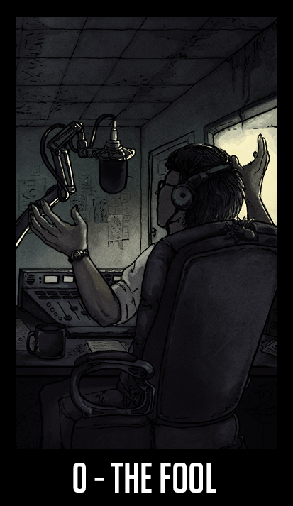
Welcome to Nightvale is a twice monthly podcast, exploring the small dessert community of Nightvale. Written and created by Joseph Fink and Jeffery Craynor, the stories that are broadcast on the town’s community radio by Cecil Palmer, are a mix of paranoia, fear and hilarity.

What I love the most about Nightvale, and why I made them one of the groups I contacted about making narrative and immersive experiences for audiences, is that the atmosphere and style of storytelling all of the pieces in this document create is an entirely different types of ‘performance’ I until now hadn’t explored fully.

Nightvale inspired my podcast, Neverware. It follows myself as the Toymaker and his team of scientists (voiced by other members of the company) as we try and survive in the junkyard wasteland of Neverware, a place where things both exist and don’t, sometimes simultaneously.

With the aid of Phillip Murphy’s musical genius, we made our first recording. What makes this podcast unique is that each episodes story is a puzzle that audiences could then report back to us with answers and we summarise the solution at the beginning of the next episode.

This dialogue was something I wanted to explore at the end of this project to see the Reponses from people experiencing different aspects of the project, and rating their own immersion into the piece as a whole, as well as all of its components.

The image seen here is an artist’s depiction of the Nightvale’s voice, Cecil Palmer, in the style of a tarot card. I found this and bought the deck as an interesting ‘other’ media.

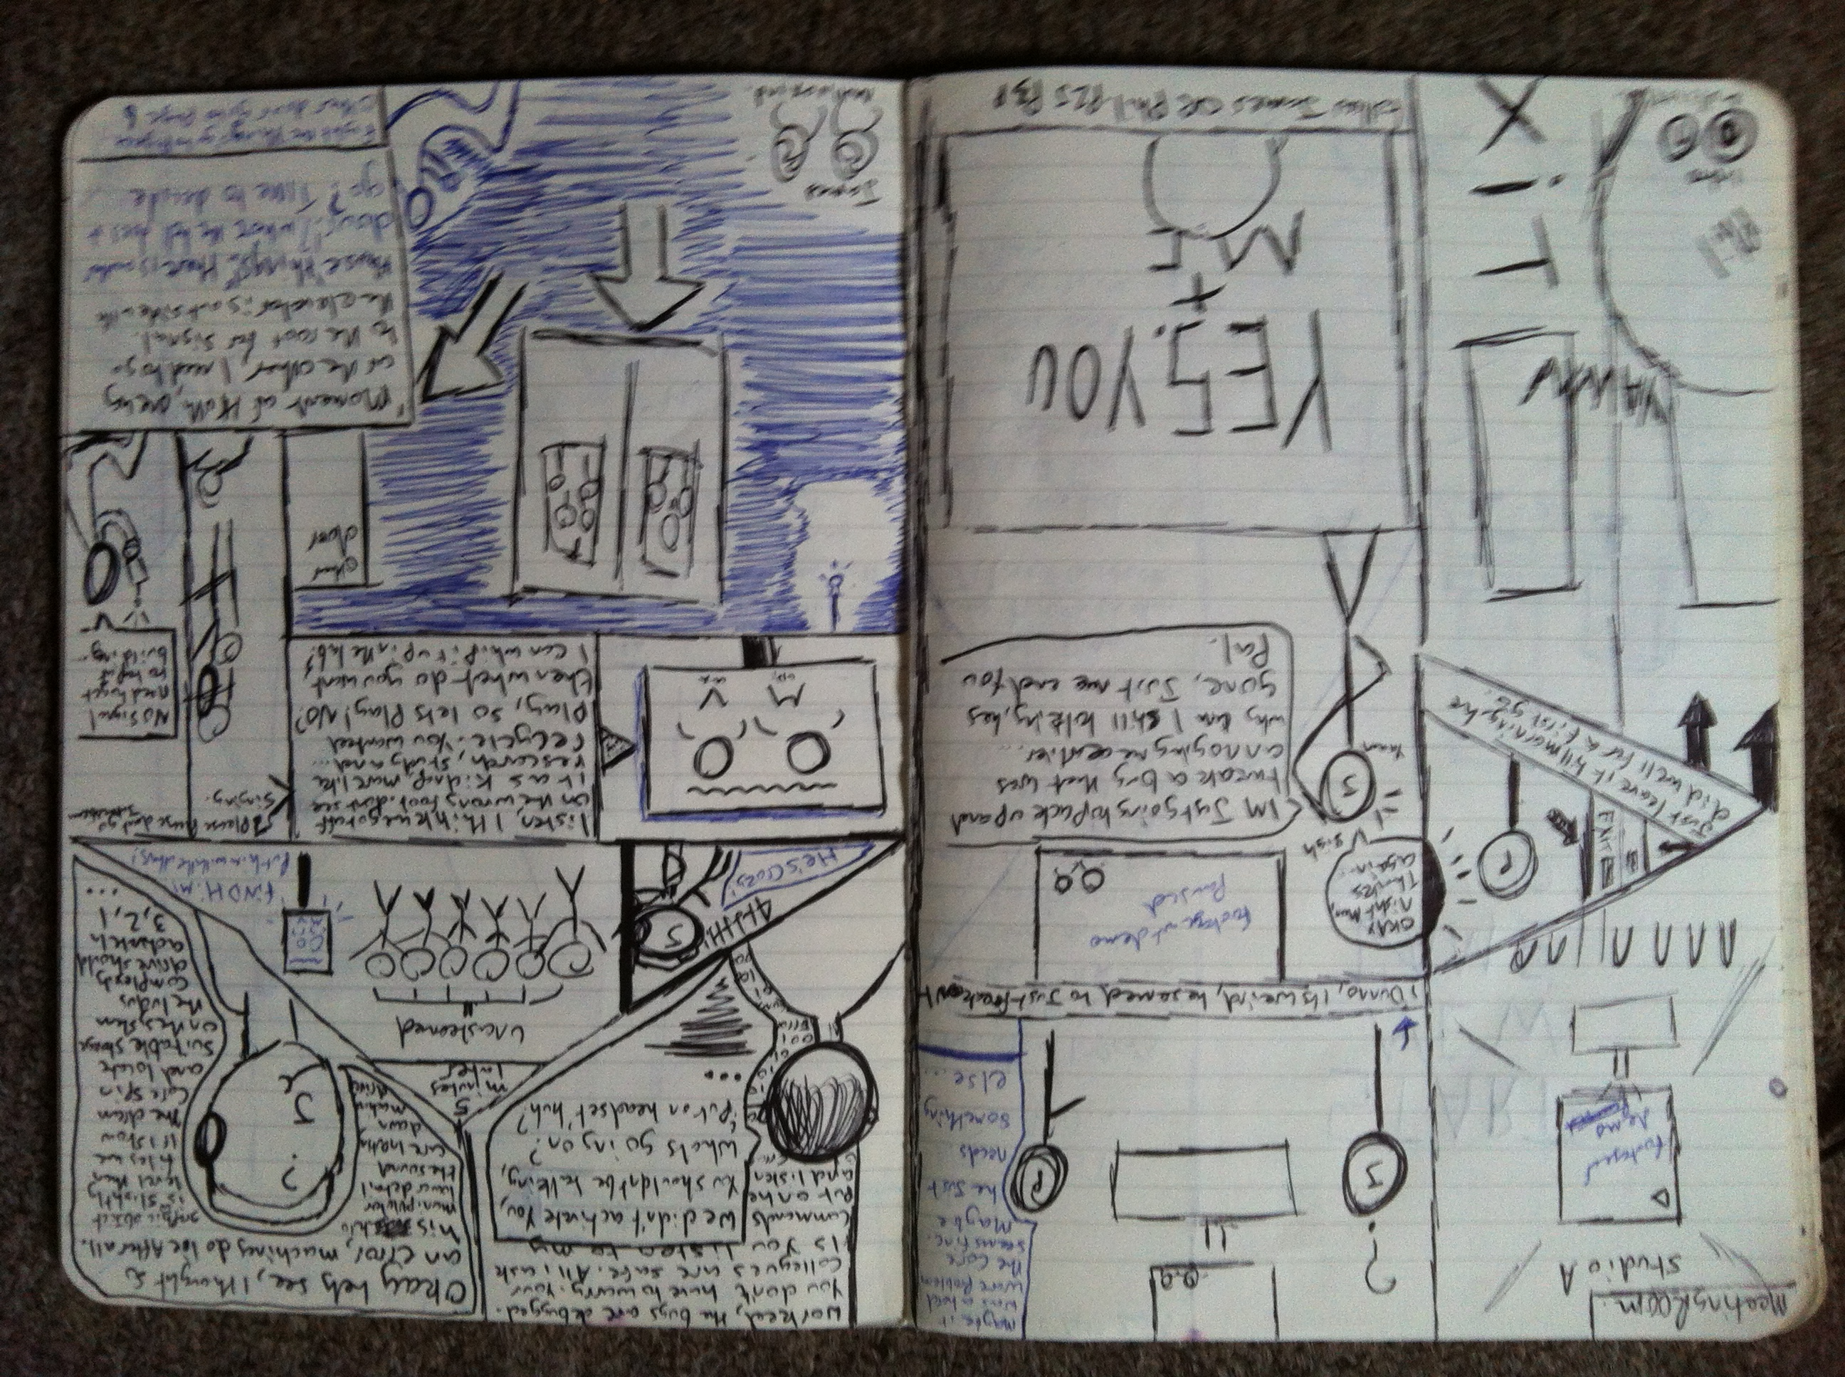The adventure comic& concept art
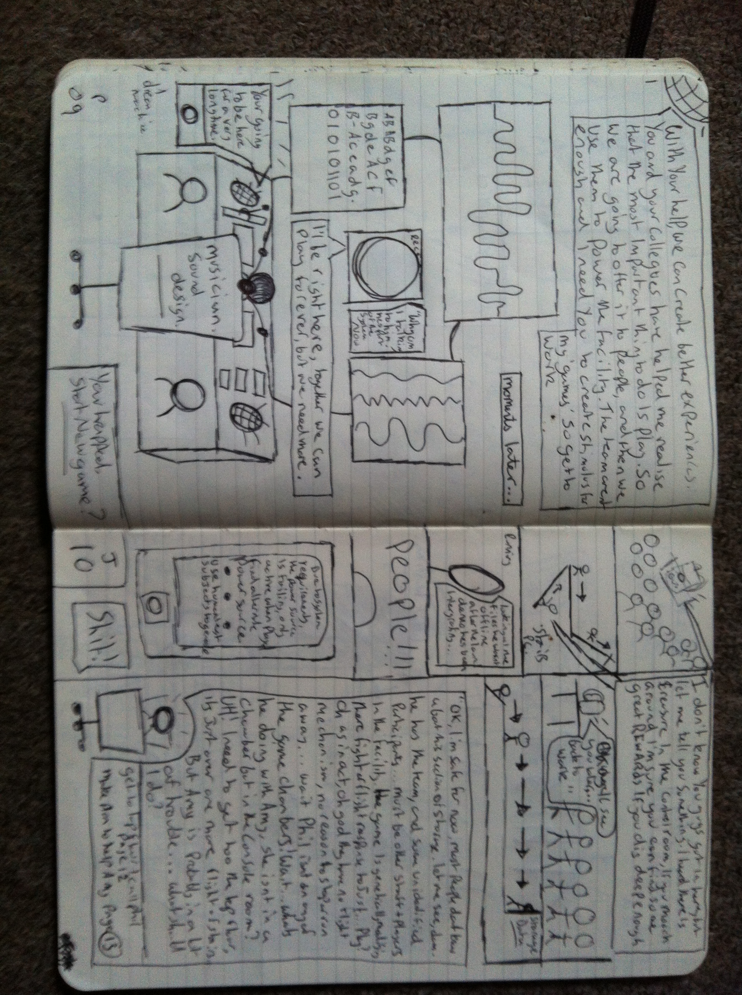

Comic
Fig7

Do you remember the monsters?Neverware characters

Fig 8
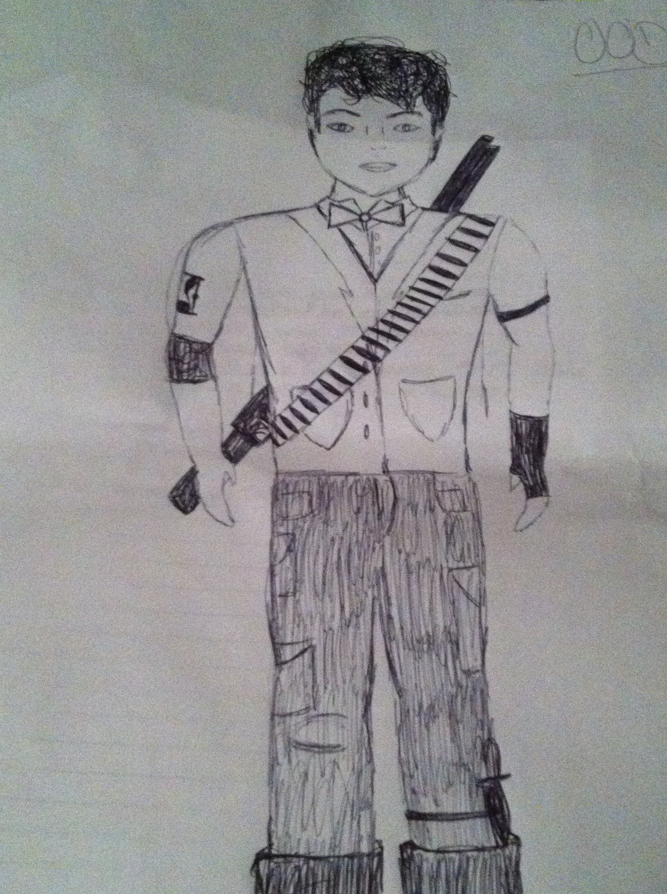
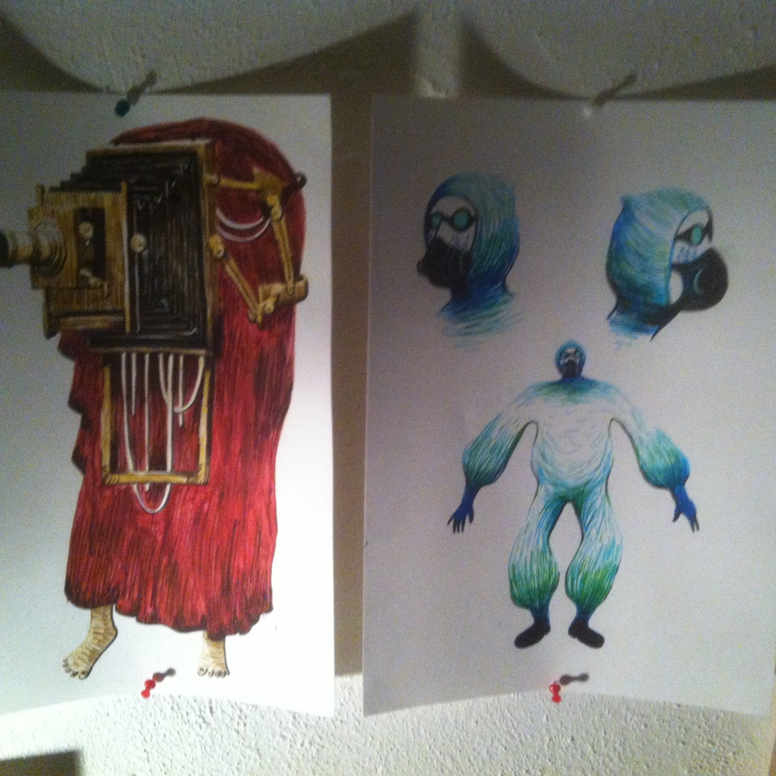

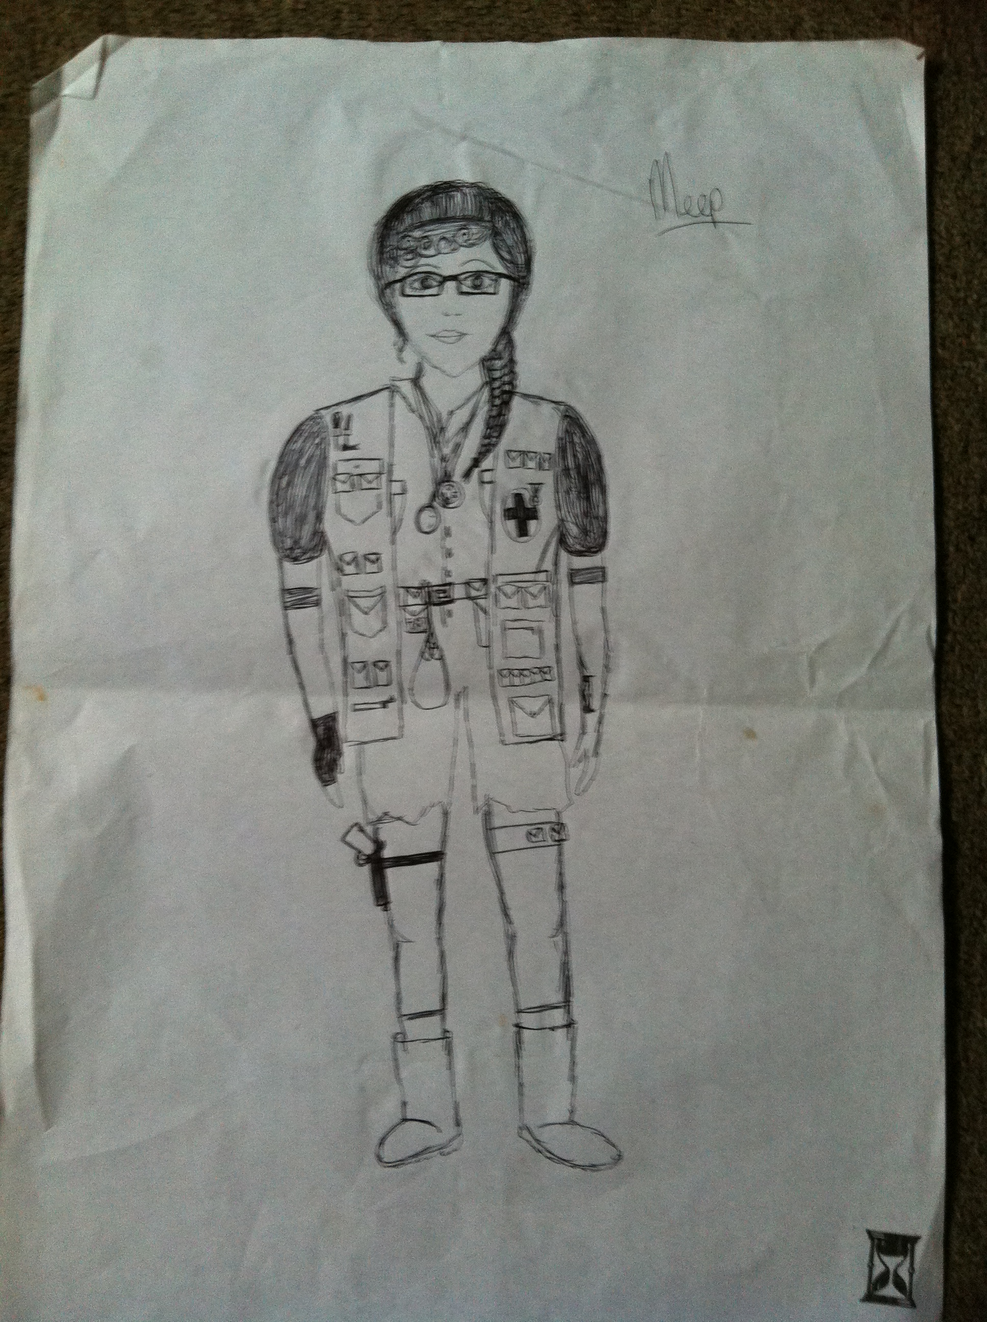

An Evaluation,

Bringing performers, artists and musician to think about play, performance and conceptual work together to create something very different from anything else I have created at University. I explored some other routes into industry through talking to people at the AIR building on campus about placements, and learnt about running a company.

I took a massive project, but realising that I could use this PIC module as a set up and ‘beginning’ of something exciting, took some time. The frustration of not being able to do something after living with it for so long is annoying.

Communication was a major problem at points, with actors I needed being busy with their own courses, and trouble with getting hold of tutors. This was overcome with the few meetings I managed to arrange with Misha Myers however, and I would like to thank her for giving me the opportunities she did. Her guidance towards the game theory and management of the project was very helpful.

I think I certainly bit off more than I could chew, but evaluating this project (and please do keep your ear out for the ‘@HOM3 performance presentation’ I will be doing, should be interesting…) through my documentation has shown me that this was overall, a very complicated project to put together. I would like to thank my fiancée’ and her parents for the love and support they have shown me through this process (and especially big thank you too Andy for helping me build the equipment!).

This project took, and is taking many forms, transmedia storytelling and ran with it. I’m very proud of the team and my own creations, the story and designs for different aspects will be something I will come back to again and again, as I definitely want to develop this further than University.

Bibliography
Adams, D, (1976) The Hitch-Hiker’s Guide to the Galaxy, Pan Books, London.
Adams, D. (1980) The Restaurant at the End of the Universe, Pan Books, London.
Adams, D. (1982) Life, the Universe and Everything, Pan Books, London.
Asimov, I. (1994) Foundation, Harper Collins, London.
Asimov, I. (2013) The Gods Themselves: SF Masterworks, Gollancz, London.
Atkins, B. (2003) More Than a Game, Manchester University Press, Manchester.
Benford, S. and Giannachi, G. (2011) Performing Mixed Reality, MIT Press, Cambridge, Massachusetts.
Blast Theory (2015) Blast Theory, URL: <www.blasttheory.co.uk> last accessed: 25.01.15
Café, G,(unknown) URL; .http://www.stanleyparable.com/, Last accessed: 21.01.16
Caillois, R. (2001) Man, Play and Games, translated from the French by Meyer Barash, University of Illinois Press, Chicago.
Cline, E. (2012) Ready Player One, Arrow Books, London.
Coney (2009) A Small Town Anywhere, URL: <http://coneyhq.org/2012/01/21/a-small-town-anywhere-2/> last accessed: 25.01.15.
Coney (2016) About Us, last accessed: 21.01.16, URL: <http://coneyhq.org/about-us/>
Cuddy, L. (2015) Bioshock and Philosophy: Irrational Game, Rational Book, Wiley, Chichester.
de Souza e Silva, A. and Sutko, D.M. (eds) (2009) Digital Cityscapes: merging digital and urban playspaces, Peter Lang, New York.
Extra Credits (2014) Design Club – Portal: Test Chambers – Tutorial Mechanics, last accessed: 21.01.16, URL:<https://www.youtube.com/watch?v=Q_AsF3Rfw8w>
Fernie, J (ed.) (Unknown) Two Minds: Artists and Architects in Collaboration, Black Dog Publishing, Unknown.
Fink, J. and Cranor, J. (2015) Welcome to Night Vale: A Novel, Orbit, London.
Giannachi, G. (2004) Virtual Theatres: An Introduction, Routledge, London.
Helmer, J. and Malzacher, F. (eds.) (2004) Not Even a Game Anymore: The Theatre of Forced Entertainment, Alexander Verlag, Berlin.
Hinske, S., Lampe, M., Magerkuth, C. and Rocker, C. (Unknown) Classifying Pervasive Games: On Pervasive Computing and Mixed Reality, last accessed: 21.01.16, URL:<http://www.vs.inf.ethz.ch/publ/papers/hinske-pg07-pervasivegames.pdf>
Moloney, K, (unknown) URL:http://transmediajournalism.org/contexts/principles-of-transmedia/#5 , last accessed :25.01.16
Montola, M., Stenros, J. and Waern, A. (2009) Pervasive Games: Theory and Design: Experiences on the Boundary Between Life and Play, Morgan Kaufmann, Burlington.
Power, E, (2015) URL: http://www.telegraph.co.uk/culture/tvandradio/doctor-who/11990021/doctor-who-sleep-no-more-review-recap-reece-shearsmith.html, Last accessed: 21.01.16

Radio Times staff,(2015) URL: (http://www.radiotimes.com/news/2015-11-14/7-questions-we-have-after-doctor-who-sleep-no-more) Last accessed: 21.01.16
Richardson, M. (2011) Valve presents: The Sacrifice and other steam powered stories, Dark Horse Books, Milwaukie.
Richardson, M. (2013) The Art of Bioshock Infinite, Dark Horse Books, Milwaukie.
Rutledge, P (2016) URL: http://athinklab.com/transmedia-storytelling/what-is-transmedia-storytelling/, last accessed 25.01.16

Rutledge, P (2016) URL:http://transmediaexperience.com/transmedia-3/what-is-transmedia/Last accessed: 25.01.16
Roland, P. (2014) Steampunk: Back to the Future with the New Victorians, Old Castle Books, Harpenden.
Salen, K and Zimmerman, E. (eds.) (2006) The Game Design Reader, MIT Press, Cambridge, Massachusetts.
Shelley, M. (2003) Frankenstein, Penguin, London.
Shirley, J. (2011) Bioshock: Rapture, Titan Books, London.
Valve (2015) Learning with Portals, URL: <http://www.learnwithportals.com/> last accessed: 25.01.15
Verity, D, (2014) URL:(https://www.reddit.com/r/Games/comments/1rcli3/the_stanley_parable_analysis/, Last accessed:21.01.16
Wheeler, J.E. (Unknown) The Practical Handyman, Odhams Press, London.

Reference list of images :
Pictures:
Fig1- (Kenny, J, (2016)’@HOM3 Logo)
Fig2- (Kenny, J, (2016) ‘Multivax Logo)
Fig3- (Kenny, J, (2016) ‘@HOM3 plan diagram)
Fig4- (Kenny, J, (2016) ‘other @HOM3 project pictures)
Fig5- (Kenny, J,(2016) ‘Creator and creation’)
Fig6- (Kenny, J,(2016) ‘Old Gus’
Fig7- (Kenny, J, (2016) ‘Concept art for Adventure comic)
Fig8- (Kenny, J, (2016) ‘Do you remember the monsters?)

Appendices:
Fig- (Kenny, J (2015)Gaant chart)
Fig- (Kenny, J, (2015) Email to Valve)
Fig- (Kenny, J (2015) Email to 2k games
Fig- (Kenny, J (2015) Email to Nightvale
Fig- (Kenny, J, (2015) Email to Extra credits
Fig-(Philpot, D (2015) Ardor letter)

James Kenny (Multivax founder)

